Introduction of DICP
Welcome to Dalian Institute of Chemical Physics (DICP), Chinese Academy of Sciences! Whether you are a part of the DICP community already, or in the process of joining us, I welcome you to one of the most vibrant and inspirational scientific research institutes in China.
Since its establishment in 1949, the research at DICP has closely reflected the scientific and economic demands of China and has been standing at the forefront of fundamental and applied science. Over the past few decades, the institute has established a long track record of major academic and industrial accomplishments in catalytic chemistry, chemical engineering, chemical lasers, molecular reaction dynamics, organic chemistry, modern analytical chemistry and biotechnology. These achievements have substantially contributed to China's economic and technological development.
DICP is home to over 1,600 scientists, engineers, technicians and administrative employees, 300 postdoctoral scholars and over 1,700 graduate students. Our faculty members include many distinguished leaders in their fields, who have received prestigious academic awards and were elected to a number of highly prestigious academic societies. These accolades are represented most prominently by 19 members of the Chinese Academy of Sciences and Chinese Academy of Engineering. Through the continuous efforts of several generations, DICP has earned a strong reputation as a comprehensive research institution covering all facets of chemical research from laboratory discovery to fundamental understanding to technology transfer paving the way to industrial applications. This is achieved in an industrious, cooperative and pleasant atmosphere that has attracted many outstanding scientists and engineers to choose our institute for launching their academic career and establishing their scientific reputations.
The central perspective of DICP is focused on addressing challenges related to sustainable and clean energy, including optimal use of fossil energy, high-efficiency chemical energy conversion and renewable energy to meet national and global strategic demands. We pursue fundamental scientific advances towards the highest levels and at the forefront of research in different fields of chemistry, and we strive to meet the most critical technological challenges towards solutions for industry. In this new era, DICP is faced with challenges but also opportunities. DICP is currently merging with the Qingdao Bioenergy and Process Institute of the Chinese Academy of Sciences, and recently both the National Laboratory for Clean Energy and Energy College of the Chinese Academy of Sciences are being built up.
Training young scientists and experts of the next generation remains our commitment. By embracing the DICP spirits "innovation, collaboration, academic rigor, excellence", DICP nurtures a highly dynamic and collaborative research community. We provide an exceptional research opportunity and environment with state-of-the art research facilities that include the most advanced scientific instruments and techniques. We enthusiastically welcome scholars and talents with inspiring creativity, strong initiative and extraordinary passion for science and technology from all over the world.
I warmly invite you to visit, collaborate with and join us at the DICP. With your input, DICP wishes to continue to develop and grow eventually as one of the world leading research institutions in chemical sciences.

Introduction of DICP Postdoctoral Research Center
Established in 1985, DICP was one of the first postdoctoral research centers in China. It houses two national outstanding postdoctoral research centers respectively in chemistry, and chemical engineering and technology. At present, there are more than 300 postdoctoral researchers (including more than 20 international ones. DICP attaches great importance to the cultivation of post-doctoral talents, and many of its postdoctoral researchers have published papers in high-quality journals, such as Science, Angew. Chem, and JACS.
Salary System for Postdoctoral Researchers

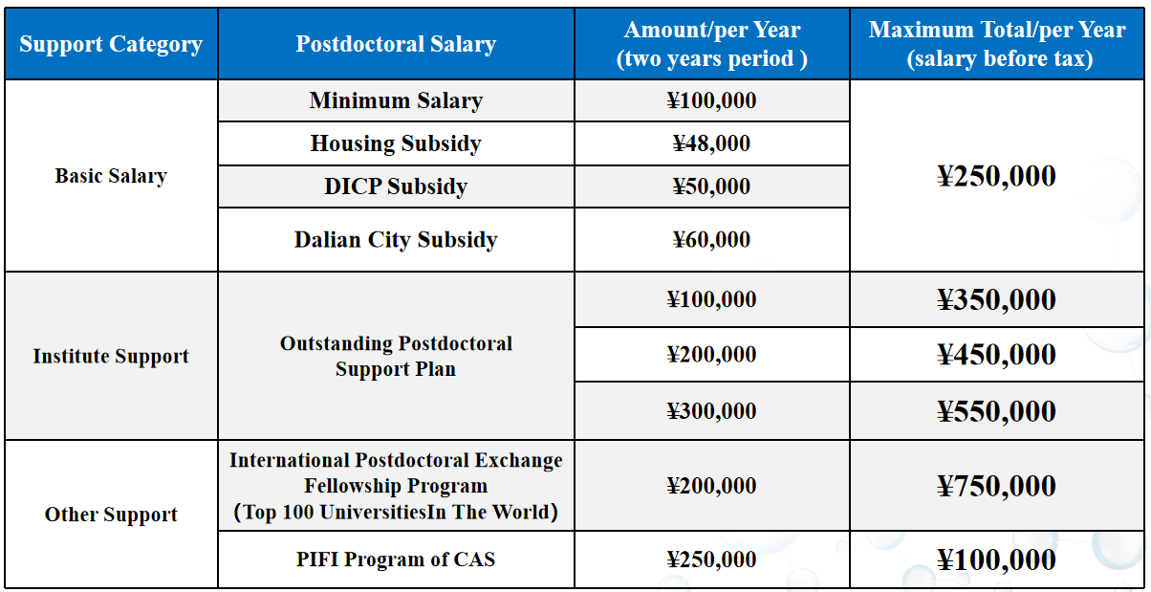

Living Facilities for Foreign Postdoctoral Researchers
DICP is located in the beautiful coastal city Dalian, surrounded by mountains and sea, and close to Xinghai Square, the largest square in Asia. Excellent geographical location enables easy access to transportation, shopping, entertainment, and other living facilities for foreign postdoctoral researchers.
In order to promote internationalization, Dalian Institute of Chemical Engineering has implemented a special project. Bilingual signs are available at office buildings, laboratories, dormitory, restaurants, and other areas in each park to facilitate use by foreigners.
DICP also provides fully equipped apartments for foreign postdoctoral researchers. The room has a kitchen, and a separate, fully furnished bedroom.

Research Systom ：http://english.dicp.cas.cn/rh_17184/rs/

Minimum Requirements:
Applicants should have received a Ph.D. in a related field within the last three years, and be 35 years old or younger.
How to apply：
To apply for a postdoctoral position at DICP (including the “DICP Outstanding Postdoctoral Scholarship”), send a cover letter, a CV, and the names and contact information of three references to Mr. Chang LIU (liuchang@dicp.ac.cn) OR an identified DICP researcher with whom you have contacted before. All applications will be reviewed, and successful candidates will be contacted. Any questions about the postdoctoral program should be directed to Mr. Chang LIU.

Mr. Chang Liu
Personnel Department, Dalian Institute of Chemical Physics, Chinese Academy of Sciences
Add：457 Zhongshan Road Dalian, P.R. China（116023）
Tel：+86-0411-84379103
E-mail：liuchang@dicp.ac.cn

